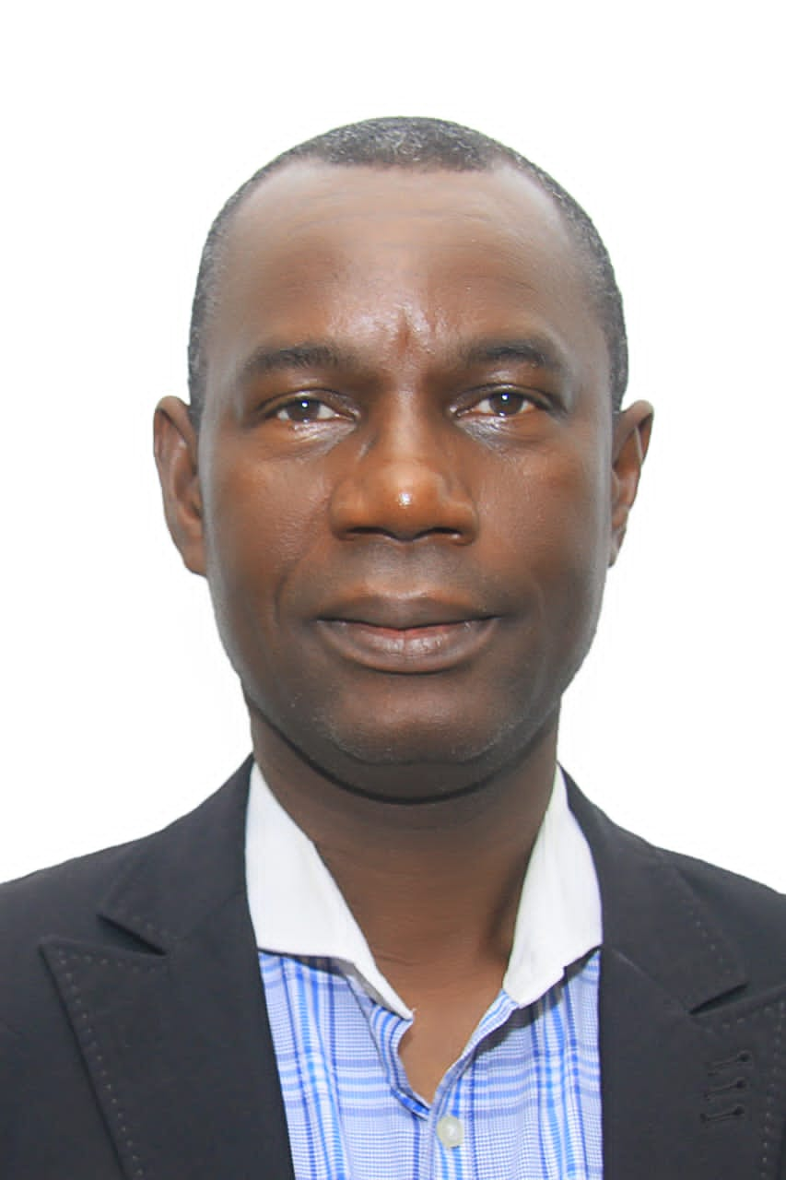

**PROFESSOR SUNDAY OJOLO, CHAIRMAN, SUPERVISORY COMMITTEE**